#OUNC2017
NCD
Athlete Package

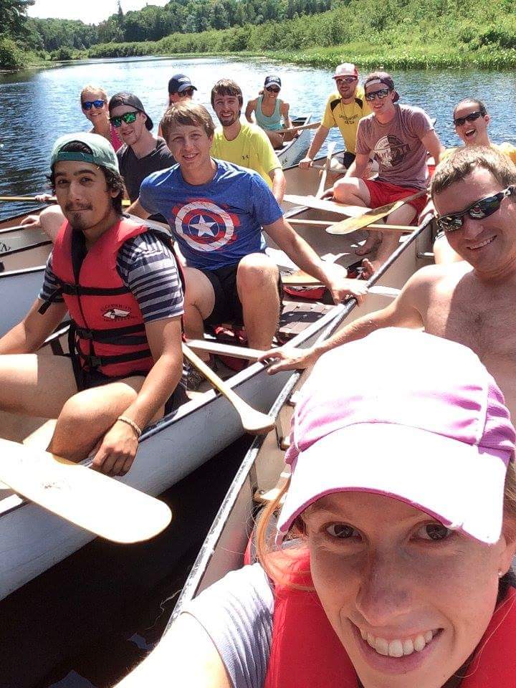

Skiers are Made in the Summer

Date: August 18-20, 2017

Location:
Carleton University
1125 Colonel By Dr.
Ottawa, ON
K1S 5B6

AND

Gatineau Park
33 Chemin Scott
Chelsea, QC
J9B 1R5

Contact:

OUNC e-mail: ouncteam@gmail.com
Shelby Dickey: ss.dickey@yahoo.ca
Meg Sinclair: sinclml@mcmaster.ca

Registration: Expense:

Expense | Cost Per Person
Accommodation | $5
Food (Saturday dinner) | $5
Activities | $15
Total | $25

Equipment Packing List:
- Running shoes
- Rollerskis, boots, poles (classic), (if anyone needs rollerski equipment, please contact Shelby Dickey: ss.dickey@yahoo.ca we will be happy to help!)
- Helmet and bright attire
- Water belt and lot’s of snacks
- Watch/heart rate monitor to time rollerski sets
- Shades and sunscreen!
- Breakfast and lunch foods
- Item for potluck (exact item to be included in e-mail)
- Road bike (optional)

Accommodation:
We are encouraging athletes to find their own accommodation for this event, however there are some billeting options that we can help set you up with. Contact Shelby or Meg if you need assistance.

Food:
Athletes will be in charge of their own food. Please bring enough food for two breakfasts, two lunches and lots of snacks for training! Each athlete will be required to bring an item for the potluck on Friday evening. Dinner will be provided on Saturday evening and is included in the price.

Social Media:

Registration: bit.ly/OUNCottawa2017
Twitter: @OUNCteam
Facebook page: https://www.facebook.com/ouncteam/

Camp Plan:

***Please note that times are approximate and subject to change
***We will accommodate alternate activities in case of extreme weather conditions

Date | Time | Activity | Total Time of Activity | Equipment Required
Friday | 5:00pm | Meet and Greet @ the Arboretum near Carleton
 | 5:15pm | Team warm-up and activities | 30min | - Running shoes
 | 5:30pm | Outdoor Strength and Core | 60min | - Running Shoes
 | 7:00pm | Potluck dinner
Saturday | 10:00am | Z1 distance adventure run @ Gatineau Park (we can check out and explain the rollerski time trial course during the run as well) | 2hr | - Running shoes  - Lots of water and snacks!
 | 12:30pm | Lunch
 | 3pm | Rock climbing @ vertical reality | 1- 1 ½ hours
 | 6:30pm | Team Dinner (provided)
 | 8:00pm | Team activities (bowls, cards against humanity etc…) |  | - Fun games!
Sunday | 8:00am (arrival)  9:00am  (first start) | Classic rollerski time trial P10 to Champlain lookout (6.5km) @ Gatineau Park | 1 ½ - 2 ½ hours | -Classic rollerskis/poles  -classic boots  -helmet  -bright attire  -snacks

